\*\*[MP's Name]\*\*

[House of Commons]

London

SW1A 0AA

Dear [MP's Name],

I am writing to you as a concerned constituent in advance of the meeting in Parliament on 25th November 2024.

The meeting is because of a petition ‘Allow students to be taken out of school for two weeks a year without penalty’

The current legislation on fining parents for non-school attendance was introduced in 2013 but was revised in August 2024. The 2013 legislation was designed to stop persistent truants, not to criminalise hard working parents that take a break once a year or Parents of sick children.

The use of fines is causing significant distress and financial burden on families who are already facing numerous challenges, particularly those with undiagnosed children with Special Educational Needs and Disabilities (SEND).

Parents are being penalised without adequate consideration of the underlying reasons for their children's non-attendance, such as mental health issues, special educational needs, and socio-economic factors.

This punitive approach does not address the root causes and instead exacerbates the difficulties these families face, potentially leading to further disengagement from the educational system.

Additionally, many schools are not authorising absences, even when children are ill, resulting in parents being unfairly fined for their children's illnesses.

We are requesting up to 10 days of 'authorised' leave per year for term-time holidays.

Many parents in certain industries are also not able to take annual leave in July/August and the pressures on the hospitality industry especially in seaside towns is immense.

Such a policy would provide families with the flexibility to plan essential breaks without the fear of fines, ensuring that children can still benefit from important family time and cultural experiences.

I would also like to draw your attention to the recent protest held on 16th November in London by concerned parents as well as the growing movement of "Protest Against School Fines." https://www.protesttofightschoolfines.com

These parents gathered to voice their opposition to the current attendance policies and their impact on families.

People are turning to drastic measures to avoid criminal records. In North Northants alone Home education has risen within 12 months by 25% and this number will only grow exponentially from here on where parents are forced into withdrawing from school because they cannot afford criminal records, which show on a DBS check as ‘failure to safeguard your children’s eeducation’

Nationally, there is a rise of Home educated children by 22% and this number will only grow until the school fines and criminalisation of parents is addressed.

Further protests are scheduled, with potential school walk-outs planned for 2025 unless these issues are addressed.

The national framework states that it is 10 sessions (5 days) before a fine/prosecution is considered. But, Local Authorities have discretion in how they implement the national framework. Some operate with zero tolerance, meaning their threshold might be as low as 2 sessions (1 day).

Meaning that there is a postcode lottery on whether you are branded a criminal or not, depending on area, and your ‘crime’ may be that your child is ill for 1 day.

It is crucial that the government changes this policy that came in in 2013 which was designed to stop persistent truants NOT to criminalise hard working parents that take a break once a year or Parents of sick children.

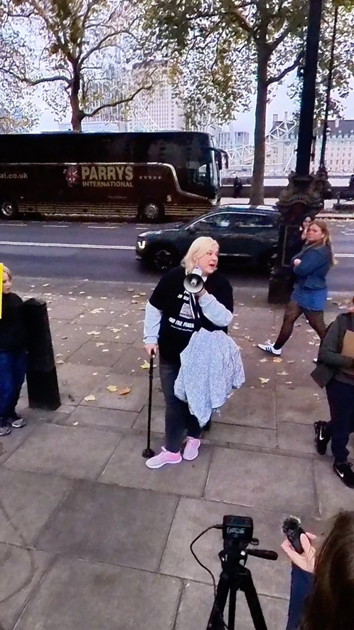A debate in Parliament would be an essential step in highlighting these issues and working towards a more supportive and inclusive education policy.

I believe that together we can foster a more understanding and flexible educational environment that recognises and respects the unique circumstances of each child. Your support in this matter would be greatly appreciated.

Thank you for your attention to this urgent issue. I look forward to your response and hope to see this matter discussed in Parliament and agree to 10 days authorised leave with an urgent look at how SEN/sickness absences are recorded.

Yours sincerely,

[Your Name here]